W-13
YEAR 10 SCIENCE EXTENSION
PHYSICS
ASSIGNMENT 3

NAME: MARK: 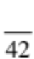

1. A car engine supplies 4.50 x 10³ N of force through the front wheels of a car and accelerates it
uniformly from rest. The mass of the car is 1.40 x 10³ kg.

(a) Calculate the acceleration of the car.

(3)

(b) Using your answer from part (a), calculate the velocity of the car after 5.0 s.

(3)

(c) Draw a velocity - time graph of the motion for 5.0 s and determine the displacement of the car.

(4)
2. A truck of mass 24.0 tonnes is moving at 80.0 kmh⁻¹ along Roe Highway when the driver notices a
small car that pulled out from a petrol station 60 m ahead. He hit the brakes sharply and just manages
to avoid hitting the back of the car. The truck ended up moving at 30.0 kmh⁻¹ and took 4.50 s to
achieve this.

Calculate the average force exerted by the brakes of the truck.

(4)

3. Explain why you "lurch forward" when standing on a bus or train and the vehicle brakes suddenly.

(2)

4. Calculate the nett force and the acceleration for the following objects. Show your calculations.

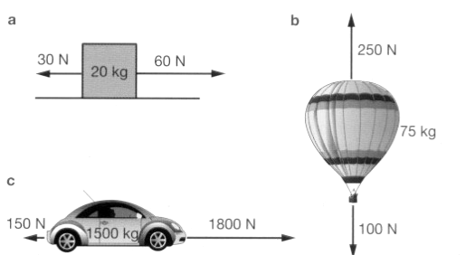

(6)
5. Which has the greater kinetic energy - a 40.0 g marble fired from a sling-shot at 1.50 x 10² ms⁻¹ or a
40.0 kg child running at 1.50 ms⁻¹? Justify your answer by calculation.

(4)

6. A pile driver is used to push piles into the ocean bed to build a jetty. A 5.50 a 10² kg "driver" falls
through 1.25 m to hit a pile.

(a) How much potential energy does the "driver" have before it falls?

(3)

(b) The potential energy becomes kinetic energy, and is a maximum as it hits the pile. Using this
information, calculate the velocity of the driver as it hits.

(3)

7. A 2.50 x 10³ kg roller coaster is moving along a smooth track at 10.0 ms⁻¹ as shown in the diagram
below.
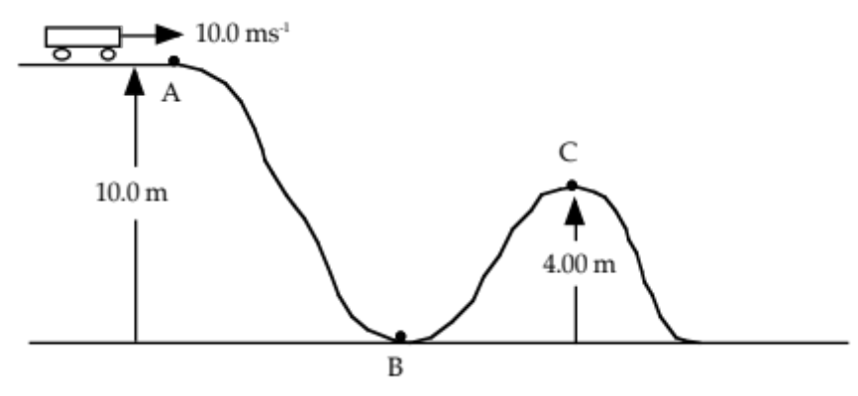

(a) Calculate the total energy of the coaster at point A.

(3)

(b) What would be its speed at point B?

(3)

(c) How much kinetic energy does it still possess at point C?

(2)

(d) In reality, your answers to (b) and (c) are incorrect. Explain why.

(2)

